



**Name**

**Primary School**





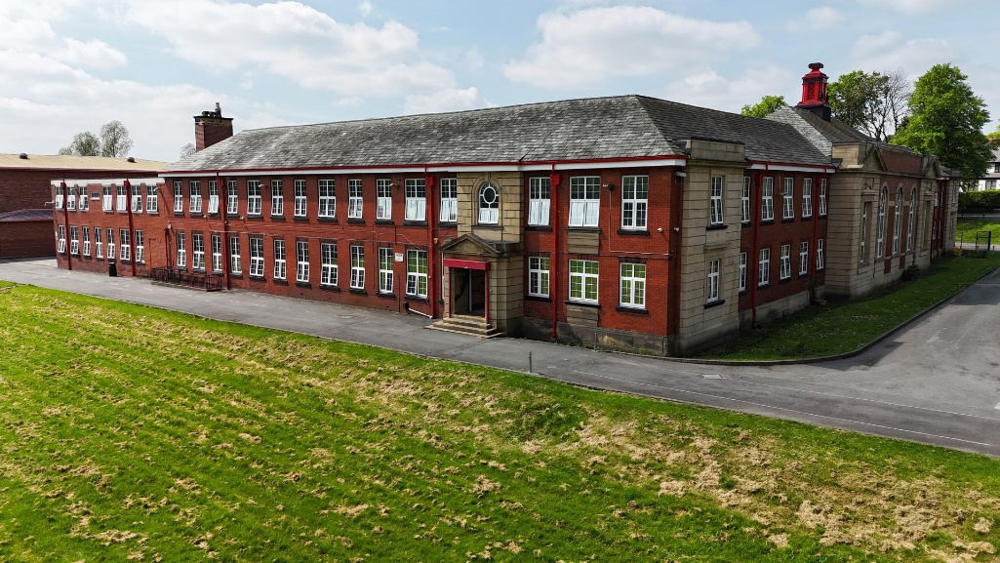

changes you will experience.

This booklet will help you get used to some of the routines and features of Philips High School.

We look forward to you being part of our school.

new

the

routines and new friends are just some of

Moving from Primary to Secondary School is an

exciting, but sometimes scary time.

A new building, new rules, new teachers,

**Going to secondary school how do you feel?**

# These could be useful to think about when you think about

changing school.

Use two different coloured highlighters, highlight the phrases that you are looking forward to in one colour; use a different colour for those you are worried about.

|  |  |
| --- | --- |
| Making new friends | Learning a new timetable |
| Dinner time | Being with my form |
| Having a different uniform | Being on time |
| Finding way around | Break times |
| Getting to school | Learning new subjects |
| Meeting others my own age | Joining clubs |
| Being with friends | School rules |
| Homework | Meeting my new tutor |
| Meeting my new teachers | Being able to do the work |
| Being with older pupils | Getting changed for sport / PE |





**Draw a self-portrait here.**

## Name: Birthday:

**My Primary School:**

**Eye Colour: Hair Colour: Height:**

|  |  |
| --- | --- |
| **Favourite Colour** |  |
| **Favourite Animal** |  |
| **If I could have a**  **superpower, I’d….** |  |
| **Favourite School Subject** |  |
| **Best place I’ve ever been to…** |  |
| **Dream country to visit…** |  |
| **If I could travel back in time, I’d go to…** |  |
| **My dream job is…** |  |





#### Life is a journey. Think back through primary school and write down your favourite memories or events next to the flags, that have shaped you to become the amazing person you are!



|  |  |
| --- | --- |
| **Full Name of the School** |  |
| **School Address** |  |
| **School Telephone Number** |  |
| **Name of the Head**  **Teacher** |  |
| **School Starts at** |  |
| **School Finishes at** |  |
| **I will get to school by:** |  |
| **How long will it take you to get to school?** |  |
| **What time will you have to leave home?** |  |

*Add 10 words around the image below to describe your new school .*

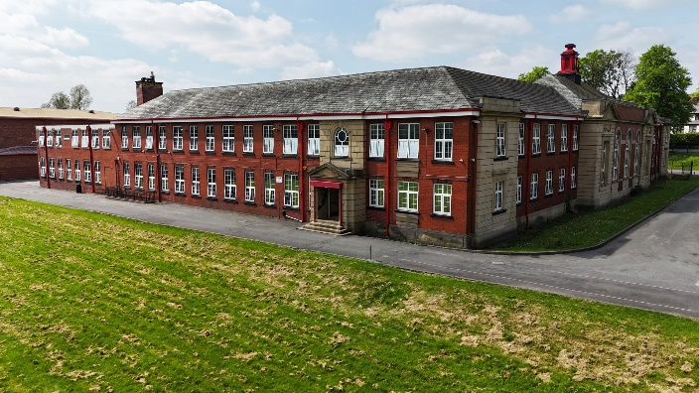

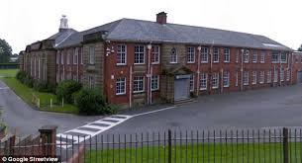

* List 4 things you are most excited about moving to Philips

High:

1.

2.

3.

4.

* List 4 things that will help you when moving to Philips High:

1.

2.

3.

4.

* List 4 differences between your primary school and Philips High:

1.

2.

3.

4.

If you or your parents/carers have any questions or worries, you can ask us by completing the google form on the website. This can be found on the transition tab. We will get back to you.





Find the subjects below in the Word search – they are vertical, horizontal backwards and diagonal!

|  |  |  |  |  |  |  |  |  |  |  |  |  |  |  |  |  |
| --- | --- | --- | --- | --- | --- | --- | --- | --- | --- | --- | --- | --- | --- | --- | --- | --- |
| M | A | F | S | E | H | M | G | E | O | H | I | M | J | E | E | R |
| F | M | A | M | W | S | L | U | S | M | I | S | E | T | T | I | E |
| R | U | D | A | N | C | E | Z | S | A | C | P | N | F | H | A | L |
| A | F | G | T | R | D | P | W | R | I | I | F | G | O | I | N | I |
| H | S | R | H | P | G | R | T | E | N | C | R | T | R | C | A | G |
| J | T | A | S | L | U | B | N | Y | R | A | E | E | M | S | S | I |
| T | U | B | J | E | I | C | Q | L | E | R | N | X | T | A | S | O |
| E | E | A | U | H | E | M | U | A | H | S | C | D | I | N | E | U |
| N | F | X | L | G | E | O | G | R | A | P | H | Y | M | D | M | S |
| G | I | M | T | V | M | A | I | T | Y | E | O | A | E | M | B | S |
| L | O | A | I | I | O | T | Y | G | O | L | O | N | H | C | E | T |
| I | P | T | E | E | L | G | R | D | U | O | E | R | A | R | Y | U |
| S | P | U | F | O | S | E | E | K | R | M | P | T | T | A | E | D |
| H | I | S | T | O | R | Y | S | C | S | A | S | M | E | L | R | I |
| E | N | J | V | E | P | I | F | J | N | O | M | U | R | S | B | E |
| J | K | C | H | A | R | A | C | T | E | R | N | A | R | P | U | S |
| Y | Z | X | T | L | S | V | Z | C | O | M | P | U | T | I | N | G |

Maths English Science Geography History

Art

Music

PE

Drama

French

Religious Studies Technology Character Computing Assembly

Form Time



**Match up the subject to the correct icon**

Maths

English Science Geography History

Art Music PE

Drama Character Religious Studies Technology Catering Computing French



Form Time



|  |  |  |  |  |  |
| --- | --- | --- | --- | --- | --- |
|  | **Monday** | **Tuesday** | **Wednesday** | **Thursday** | **Friday** |
| Form Time  08:40-09.00 | ASSEMBLY | ADMIN/  PLANNERS | PERSONAL DEVELOPMENT | PERSONAL DEVELOPMENT | LITERACY |
| Period 1  09:00-10:00 | ENGLISH  VHD F24 | MATHS  SBE F4 | FRENCH  JBA G14 | GEOGRAPHY  JDD G18 | PE  DSY G10 |
| Period 2  10.00-10:55 | SCIENCE MDS F23 | HISTORY  TBT F13 | HISTORY  TBT F13 | DRAMA AES F14 | CHARACTER SHD G5 |
| BREAK 10:55-11:15 | | | | | |
| Period 3  11:15-12:15 | ART  LGS G27 | PE  PCI SH | MUSIC  SAF G19 | ENGLISH  VHD G24 | ENGLISH KEO G24 |
| Period 4A  12:15-12:40 | GEOGRAPHY  JDD F7 | SCIENCE  JPS F18 | ENGLISH  VHD G24 | MATHS SBE F4 | FRENCH  JBA G14 |
| LUNCH 12:40 – 13:15 | | | | | |
| Period 4C  13:15 – 13:50 | GEOGRAPHY  JDD F7 | SCIENCE  JPS F18 | ENGLISH  VHD G24 | MATHS SBE F4 | FRENCH  JBA G14 |
| Period 5  13:50-14:50 | MATHS  SBE F4 | COMPUTING  TKL G9 | RE  CSE F1 | TECHNOLOGY  EDS G23 | SCIENCE MDS F23 |
| DETENTIONS 15:00-16:00 | Detentions run every day for pupils who have behaviour points on a day. | | | | |

MATHS SUBJECT SBE F4

INITIALS OF TEACHER ROOM

**At high school we move rooms for EVERY lesson.**

* The rooms start with a ‘G’ or an ‘F’ what do you think these mean?

……………………………………………………………………………………………

* How many minutes does each lesson last? …………………………………
* How long is lunch and break combined? …………………………………...
* How many times a week would you have:

Maths?...................................... English?: ……………………………………..

* Which days would you need your PE kit? ………..…………………………

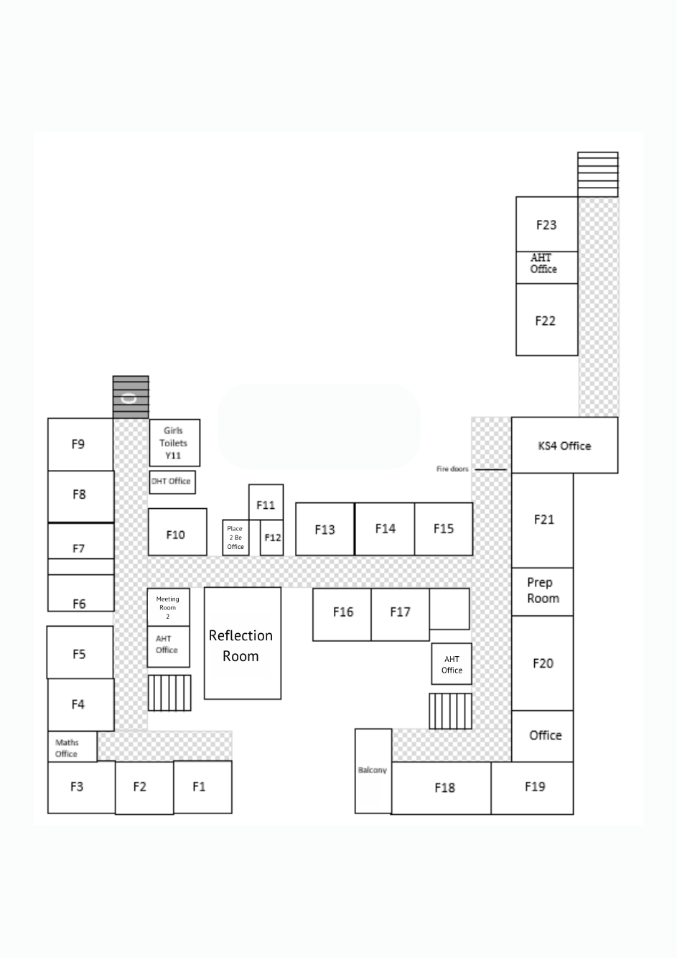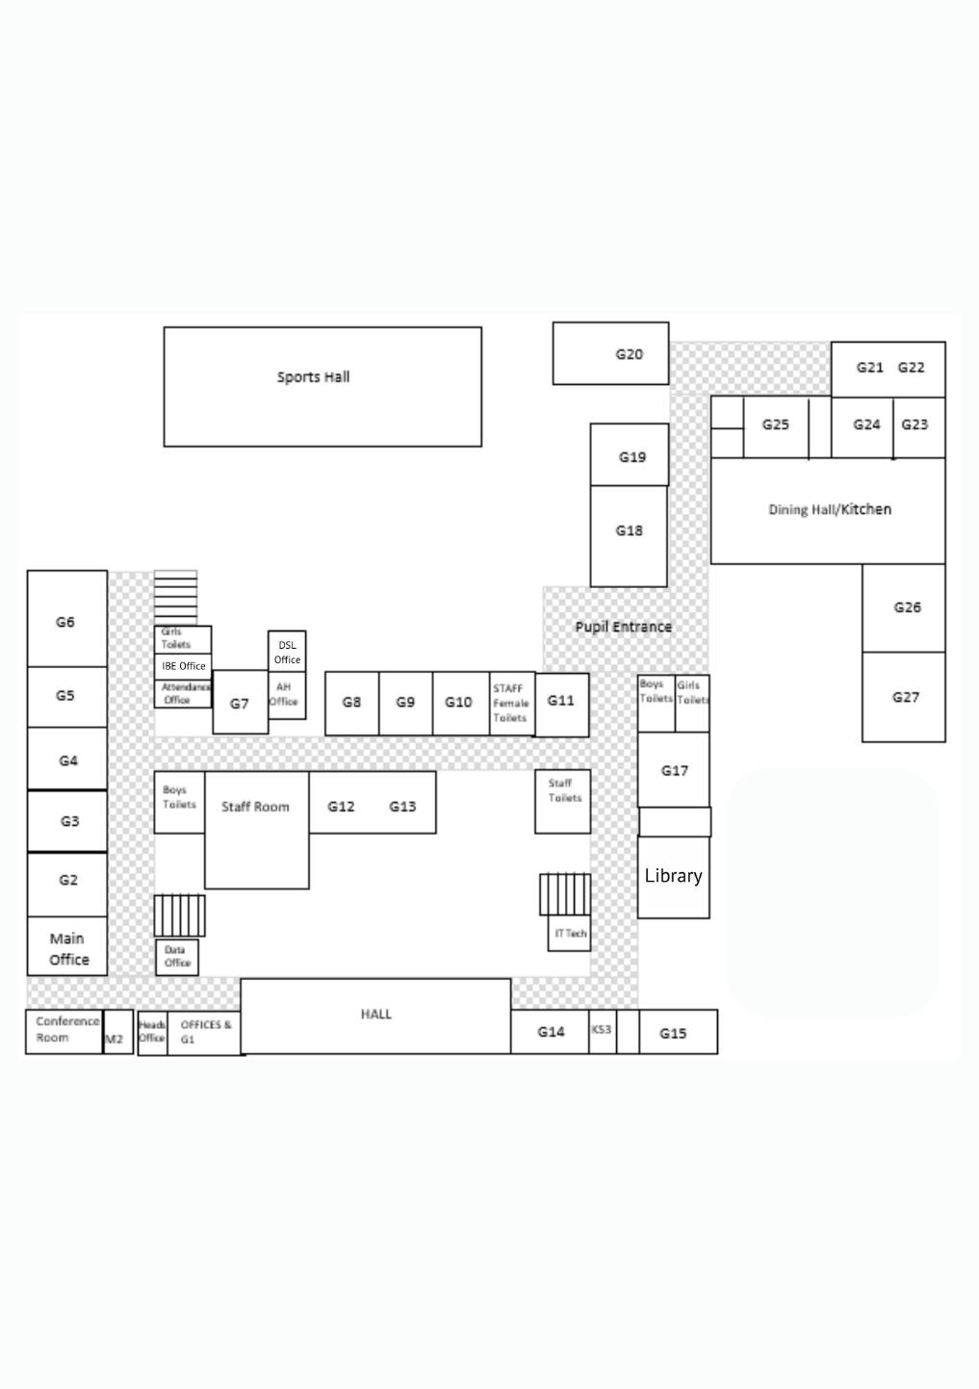

On the **GROUND** floor you will find classrooms **G1-G27** for:

* English
* Computing
* French
* Technology
* Drama
* Music
* Art
* Hall
* Canteen

On the **FIRST** floor you will find classrooms

**F1-F23** for:

* Maths
* History
* Geography
* Religious Studies
* Learning Support
* Science
* Library
* KS3 Hub

**First Floor**

**Ground Floor**







Getting to Philips High School safely is just as important as being there. In the box below, draw the route you are going to take to school (whether that’s walking, cycling, driving or by bus). Identify spots where there could be hazards (e.g. busy roads) and explain how you will manage this safely!





#### At secondary school, you will be moving around to different classrooms for different lessons. You could be in 7 classrooms in one day. This means that you need to bring all the equipment you will require with you for the day. You can keep larger items such as your PE kit in your locker, however you can only go to your locker before school, at break and lunchtime and at the end of the day.

**YOU WILL NEED TO BE ORGANISED!**

What basic equipment do you need to bring with you every day when you start at Philips?



What subjects will you be studying in your first year at Philips?

**REMEMBER TO LOOK AT YOUR TIMETABLE EVERY NIGHT AND PACK YOUR BAG THE NIGHT BEFORE YOU GO SCHOOL!**

#### What else will you need to bring to school on some days?

What will be your morning routine?

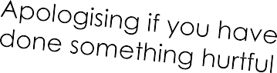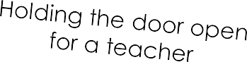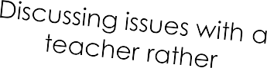

Be a STAR at Philips High School. Our core values and expectations at Philips are all linked through STAR:

**SUCCESS, TOGETHER, ASPIRE, RESPECT**

This applies to the way we choose to conduct ourselves, the way that we behave towards other people, and the way that we behave in our lessons. They are expectations, because we are expected to behave in this way; it is not a choice.

The expectation that we have is that we all behave in a way that means that we are calm, collected and respectful towards one another, and that we arrive for our lessons punctual and prepared.

### Match the correct description to each letter of the STAR logo.

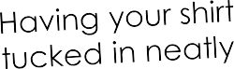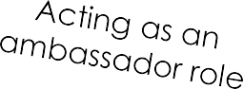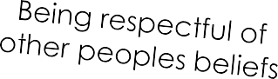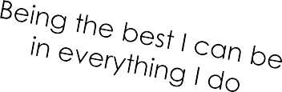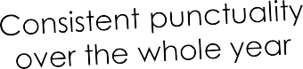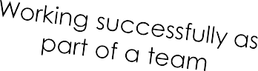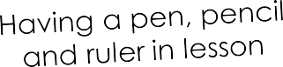



Contributing to lessons

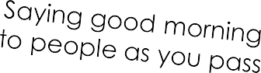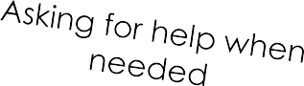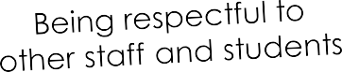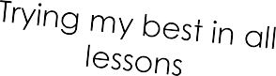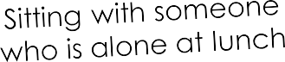





|  |  |
| --- | --- |
| **What positive behaviour have you seen in**  **your primary school and in your lessons?** | **What negative behaviour have you seen in**  **primary school and in your lessons?** |
|  |  |

**Respect**

**What is respect?**

**In what ways should pupils need to show respect at Philips High School?**







One of the different things about moving to secondary school is the change in what you will wear. At Philips High School we pride ourselves in looking smart and professional at all times. Use the school website or the information booklet to draw and label the school uniform you will wear onto the Lego figure.

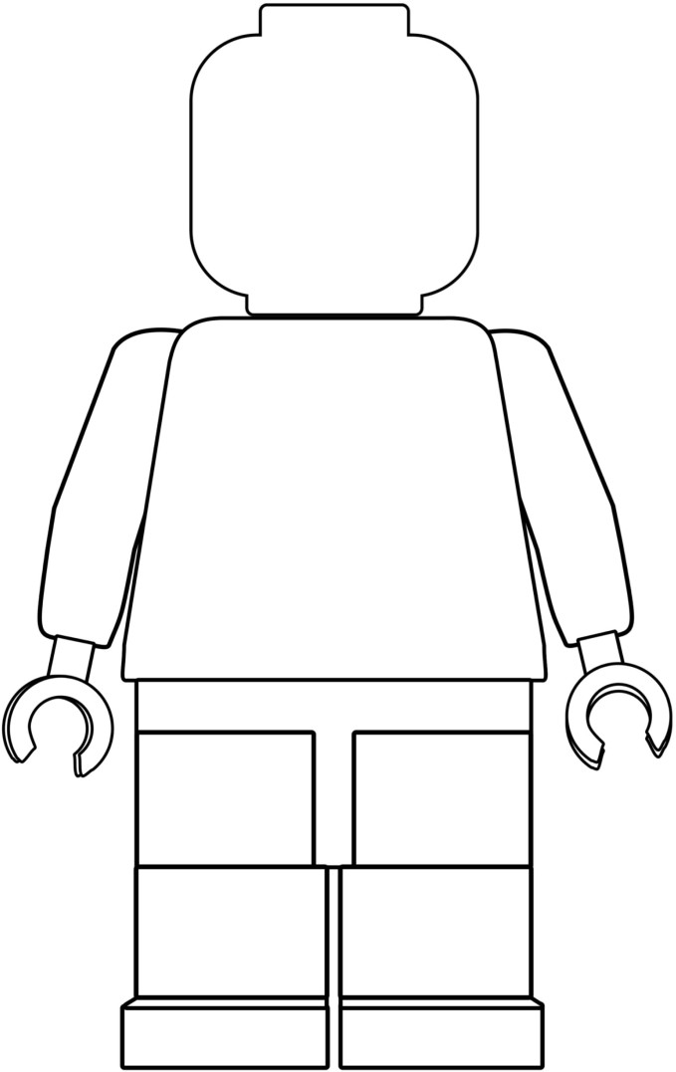

Why is wearing the correct school uniform important?