# Welcome to Philips High School

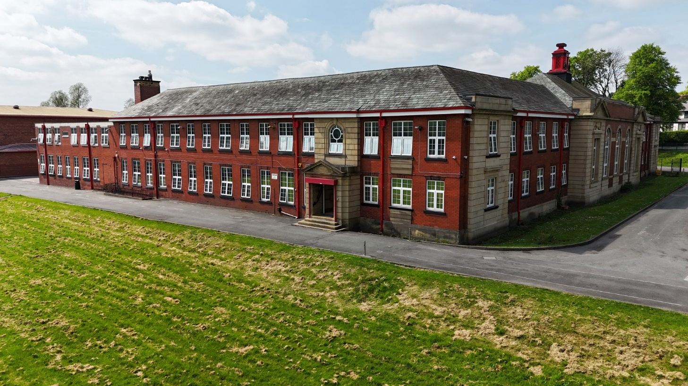

### Transition Information 2025

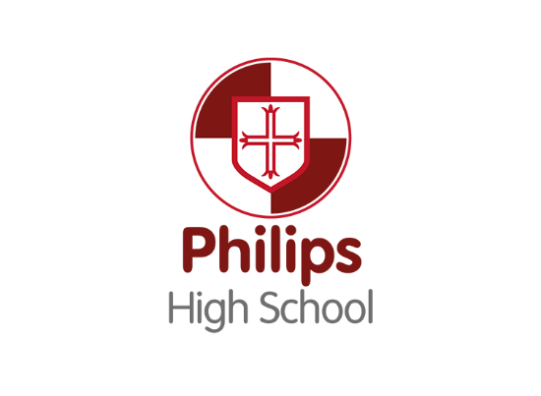

Welcome to Philips High School!

**Transition 2025**

Congratulations, if you are joining us in September as part of our new Year 7, we are looking forward to you being part of the Philips High School family and want you to feel welcome.

Moving to a new school is exciting and scary at the same time. Here is some information to help you

with your move from primary to secondary school.

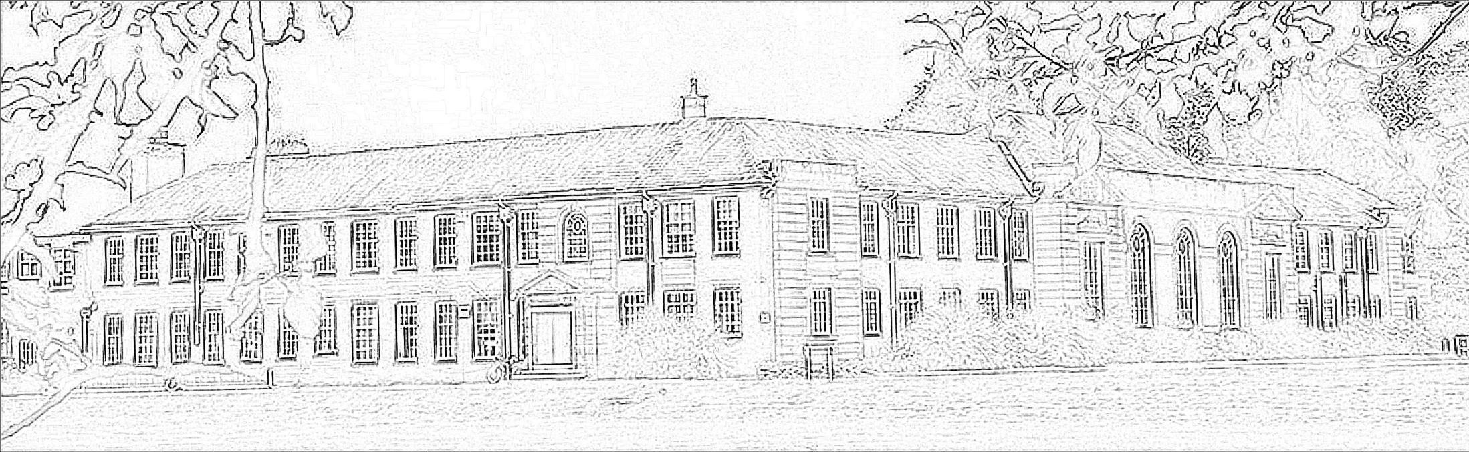

## Be a STAR at Philips High

At Philips High everything we do is linked to our core values:

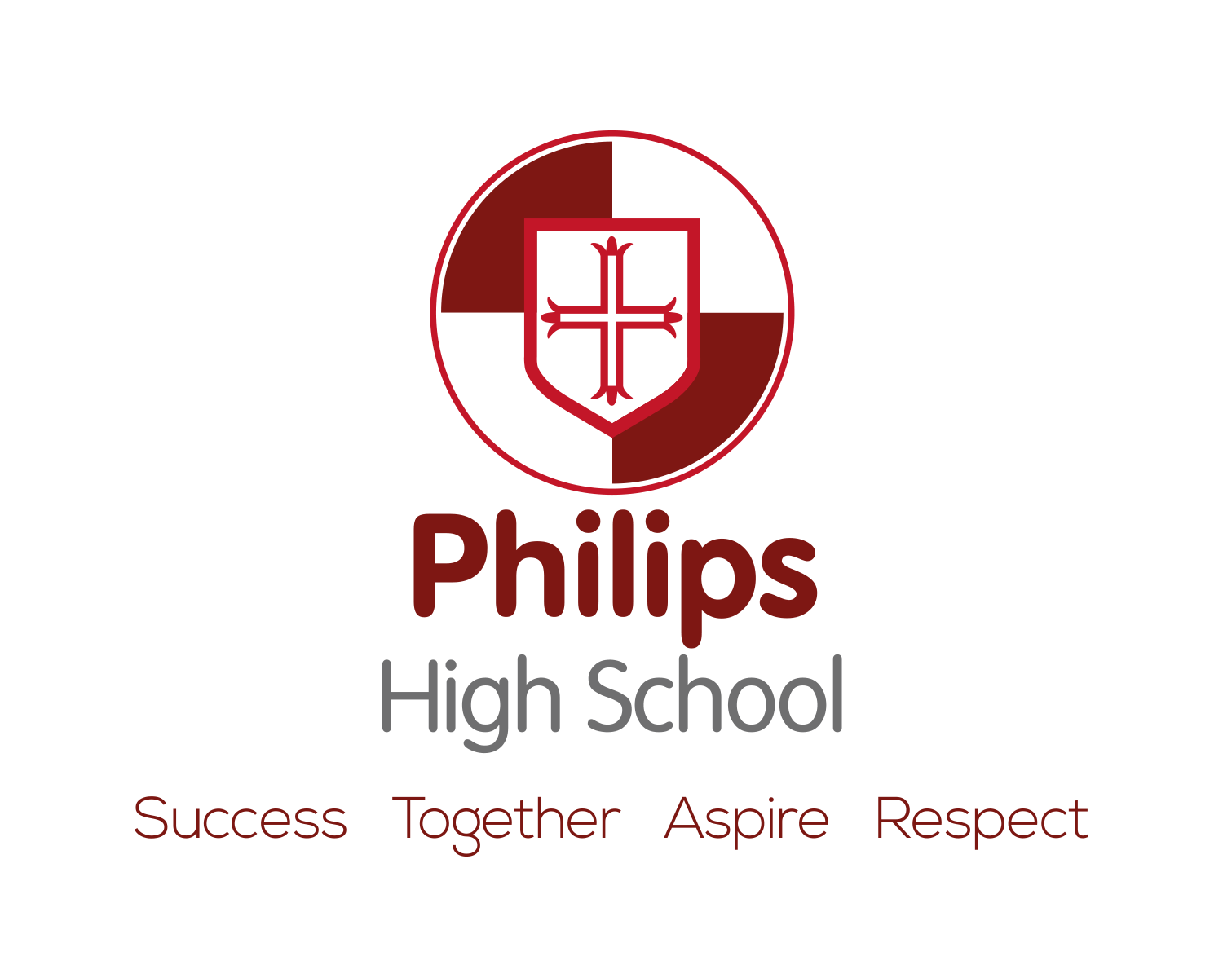**S T A R**

* **Striving for SUCCESS**
* **Working TOGETHER**
* **ASPIRE to excellence**
* **RESPECT for all**

**How are you going to be a STAR at Philips High?**



**Form Groups**

Each year is divided into 6 form groups with a form tutor.

You will be with your form 20 minutes each day. Your form is like your school family. You will stay with them all the way through High School.

Throughout the year there are competitions with other forms for attendance, sports day and various challenges. You will make lifelong friends in form – your Philips family!



## The School Day

At High School you always start the day with your form tutor. Each lesson is a different subject,

with a different teacher, in a different room.

|  |  |  |
| --- | --- | --- |
|  | **Year 7 & Year 8** | **Year 9, 10 & 11** |
| **Warning Bell** | 8.35 | 8.35 |
| **Registration/Assembly** | 8.40 - 9.00 | 8.40 - 9.00 |
| **Lesson 1** | 9.00 - 10.00 | 9.00 - 10.00 |
| **Lesson 2** | 10.00 - 10.55 | 10.00 - 11.00 |
| **Break** | 10.55 - 11.15 | 11.00 - 11.15 |
| **Lesson 3** | 11.15 - 12.15 | 11.15 - 12.15 |
| **Period 4** | 12.15 - 12.40 | 12.15 - 1.20 |
| Lunch 12.40 - 1.15 |
| 1.15 - 1.50 | Lunch 1.20 - 1.55 |
| **Lesson 5** | 1.50 - 2.50 | 1.55 - 3.00 |
| **End of School Day** | 2.50 | 3.00 |



## Subjects Taught in Year 7

* + English
  + Maths
  + Science
  + Geography
  + History
  + Religious Studies
  + French
  + Computing
* Food & Nutrition
* Design Technology
* Drama
* Music
* Physical Education



## Attendance

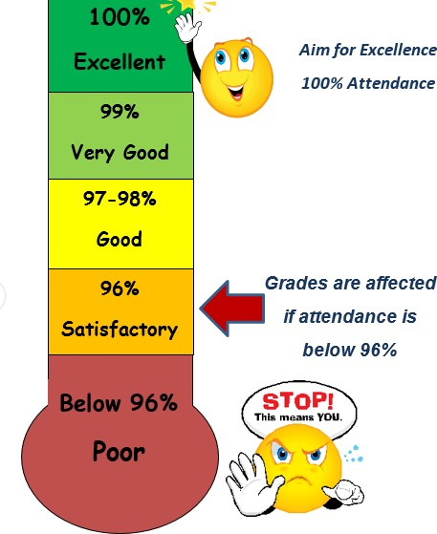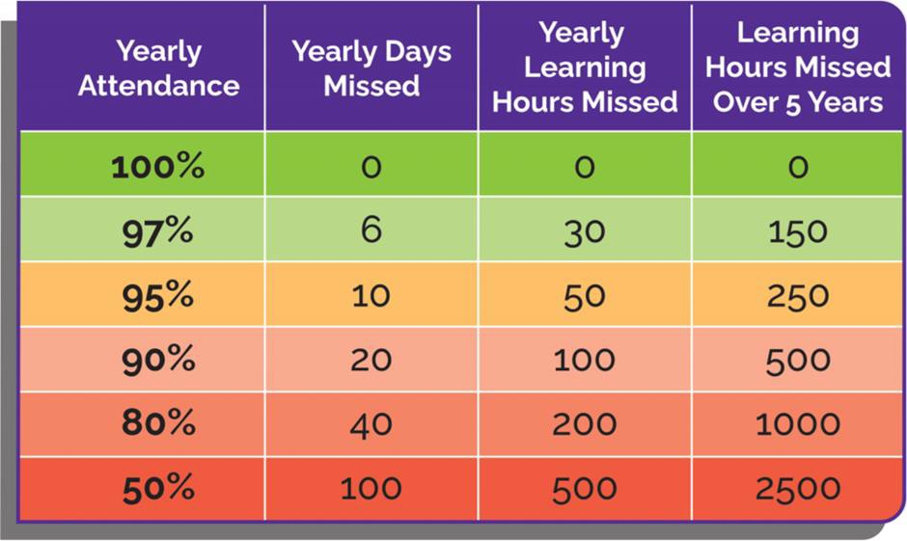



**Independent Study**

Year 7 pupils will receive about two subjects per day. To start with, you will only have independent study for English, Maths and Science.

This comes in many forms, depending on the subject. Examples include research, a spelling test, a quiz,

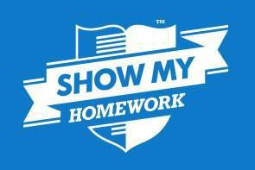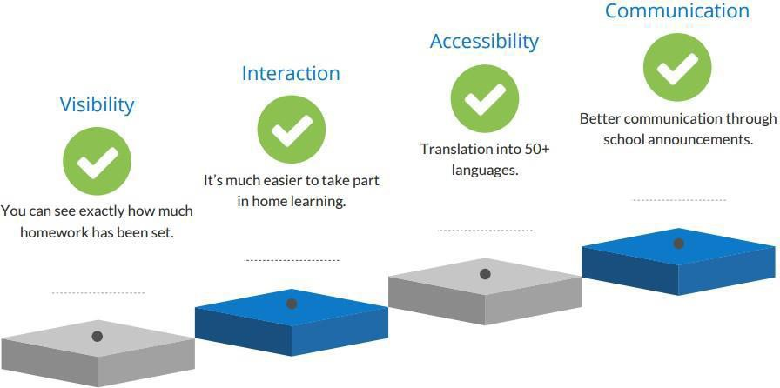an essay, reading about a topic…



## A Positive Learning Environment

We want you to feel safe and secure in your learning environment so you can make progress and reach your full potential.

#### We expect:

* + Full attention when the teacher is talking
  + Pupils to be focussed on their own work.
  + Respectful listening when others answer or give an opinion.
  + Comments to be constructive
  + Manners to be used
  + School rules to be followed.



## Classroom Respect Expectations

We want your child to feel safe and secure in their learning environment. So they can progress and reach their full potential. To do this everyone need to respect the learning environment and the pupils/staff within it.

#### Behaviours that will NOT be accepted:

* + Distracting others whilst working in lessons.
  + Talking whilst the teacher is talking.
  + Shouting out or disrupting others’ learning.
  + Answering back or arguing with the teacher.
  + Making inappropriate comments.



**REWARDS**

**Rewards & Sanctions**

**SANCTIONS**

* + - Positive house points
    - Postcards home
    - Signed gold card
    - Achievement assemblies
    - Prize draws
    - Certificates
    - STAR badges
    - Rewards trips
    - Negative behaviour points
    - Lunch time corrections
    - Corrections
    - Report cards
    - Reflect



## School Uniform

##### At Philips High School pride in pupils’ appearance is central to our message of high

**expectations and aspirations.**

* + Smart, business-like
  + 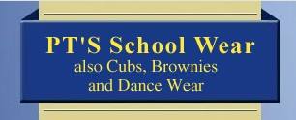No leggings or black jeans
  + No piercings, makeup, painted or false nails, jewellery
  + No hoodies to be worn in school
  + Shoes – flat, black – **no trainers, no logos**
  + Long hair need to be tied back in all practical lessons – using plain bands or slides.

School uniform can be purchase from: PT’s School Wear & Monkhouse School Wear

PE kit can be purchase from Macron. 



## Where can I get help?

If you ever need any help or support, there are lots of people you can turn to. There are also many websites you can visit too. In school you can get support from:

* + Form Tutor
  + Head of Year
  + Class teachers
  + Place2Be (our emotional and wellbeing support service)

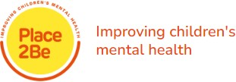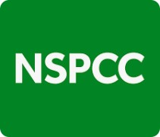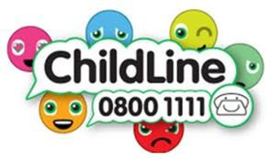



## Be Prepared

This basic equipment is checked every lesson, make sure you have it with you at all times. You will also need a school bag to carry your books in.

* + Pupil Planner
  + Red Pen, Black Pen
  + Calculator

• Pencil

• Ruler

• Maths geometry set



## Breakfast Club, Break & Lunch

* + Breakfast club is in the canteen from 8am
  + A free breakfast is available to anyone who wants it
  + 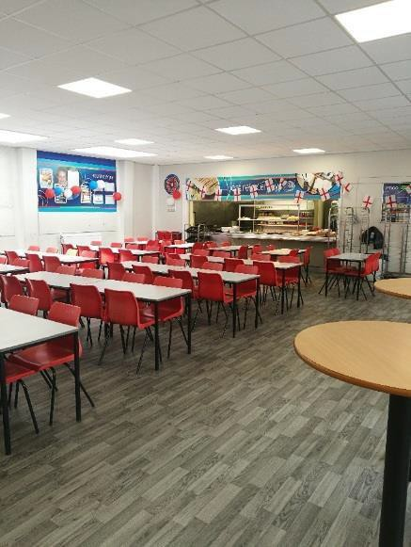At break you can go to the canteen, library or outside
  + You should go to the toilet during break as they are locked during lessons
  + At lunch, you need to take your bag back to your form room PROMPTLY then go to the canteen to have your lunch.
  + 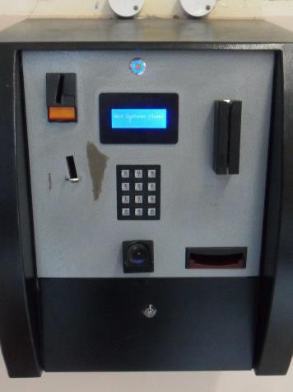You are then to go outside/go to a club/go to the library.





## You can keep up to date with us on:

This basic equipment is checked every lesson, make sure you have it with you at all times. You will also need a school bag to carry your books in.

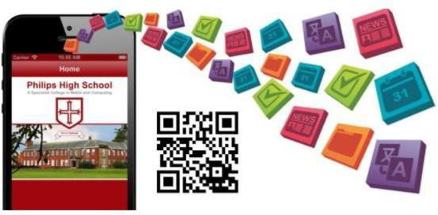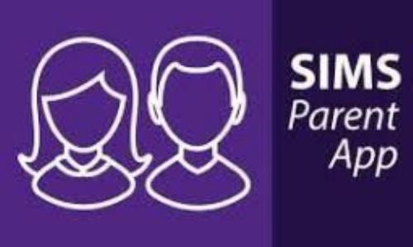

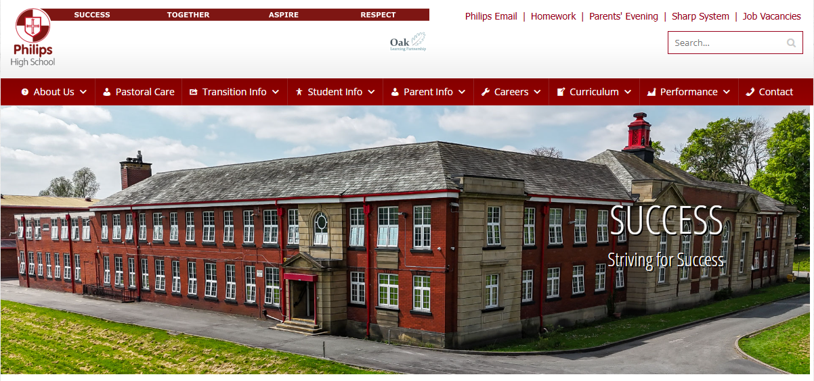

https://www.philipshigh.co.uk/



## Finally…

There is a transition workbook available to download and print from our school website: <https://www.philipshigh.co.uk/transition-information/>

We look forward to you joining us in September, so you too can be a STAR at Philips High School.

